Final Exam Study Guide-6th Grade Name__________________________________________

You may need to make notes on another sheet of paper to study for the test. In addition, you need to review all tests, notes, and quizzes.

**Nature of Science (NOS)**

What is the difference between a theory and a law? Can they both change? Explain **Theory explains a natural phenomenon (why its happening and how its happening), A Law tells you what is happening naturally. A law does not change, more may be added but it does not change. A Theory can change based on new evidence that is supported by science or repeat findings.**

**A theory explains a natural phenomenon and a Hypothesis is an educated guess about what may happen. Both can be tested**

1. What is the purpose of a scientific law? **A scientific law is meant to tell you what scientific phenomenon is happening.**
2. What is the difference between a theory and a hypothesis? **A theory is a hypothesis that has been tested and supported many times over. A theory explains why a natural phenomenon is taking place. A Hypothesis is an educated guess or a statement that can be tested.**
3. Why do we often use models in science? What are some limitations of models? **We use models to give us a visual of what is happening or to represent what we see in nature. Limitations of models include the following: 1. They may not be to scale, parts may be missing,**
4. Define the following:
   1. Independent Variable: **The variable that is changed by the scientist**
   2. Dependent Variable: **What is being measured**
   3. Constant : **A variable that remains the same during an experiment. This does not change**
5. Mrs. Gamble wanted to know if the growth of basil plants is affected by how often the plants are watered. He grew two groups of basil plants. He watered the plants in Group 1 every two days. He watered the plants in Group 2 every seven days. Each group was given the same amount of water each time the plants were watered. What is the independent variable in this investigation? **How often the plants are watered**
6. Identify/ circle the independent variable in this experiment:
   1. Mrs. Gamble planned a science fair experiment that tested the effect of different light sources on the growth of Lilly Plants. To conduct the experiment, she placed one group of ten Lilly plants in the front window, then placed another group of ten Lilly plants under a light fixture with special light bulb for plants
7. Write Observation or Inference next to the statement.
   1. The ground is wet , it must have rained **Inference**
   2. The flower is red **Observation**
   3. She made an A on her test, she must be smart **Inference**
8. A student collects data on the effect of paper color on the change in temperature (in degrees Celsius) after sitting in the Sun for 30 minutes. Which of the following is a constant variable in this experiment?
   1. The size of the paper
   2. The color of the paper
   3. The temperature
   4. **The amount of time sitting in the sun**

**Earth Science**

1. What is a convection current**? There rising and falling of liquid based on the temperature of the liquid. Cycle- Hot air/liquid rising and cold air/liquid falling**
2. List the three places convection currents take place: **1. The ocean 2. The mantle 3. The atmosphere**
3. What is the main source of power for convection currents? **Energy from the core of the earth**
4. Define the 3 types of heat/energy transfer below. Give an example
   1. Conduction: **energy transfer due to direct contact – pancakes in a pan**
   2. Convection: **Energy transfer through a liquid, changes in temperature (hot air rising, cool air sinking )**
   3. Radiation: **Heat transfer through the air**
5. Name the wind pattern on the map next to the number

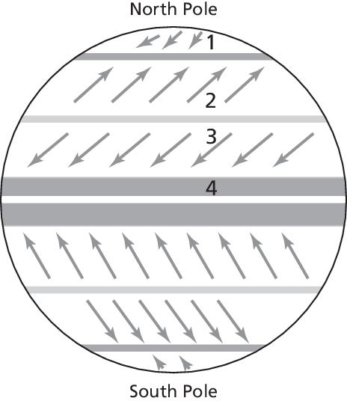

1. **Polar Easterlie**
2. **Westerlie**
3. **__Northeast Tradewinds**
4. **Equator**

15. Define Air Pressure. Which type of air will have more pressure? **Cold air** or Hot air

16. Which of these statements **best** describes weather?

**A. It rained 2 centimeters this morning.**

**B.** The average yearly rainfall for this city is 42 centimeters.

17. Which description is determined by the average yearly rainfall?

**A. a region’s climate**

**B.** a region’s weather

**C.** a region’s humidity on a particular day

**D.** a region’s temperature on a particular day

18. List the types of damage that can happen to your home or personal property as a result of a hurricane: Example Flooded rooms.

19. List 2 warning signs for a sinkhole: for example- cracks in walls and floors, cracks in the ground, small ponds of rainfall that form in new places. **Cracks in walls, cracks in the ground, plants or grass wilted (circular), sagging or crooked trees**

Energy

1. Define the following:
   1. Potential Energy: **Possible energy something has**
   2. Kinetic Energy: **energy from movement**
2. Niheem is riding a ferris wheel at the fair. When does he have the most potential energy? Choose one
   1. At rest :
   2. Moving the fastest
   3. **When he is furthest from the ground?**
3. How does the Law of Conservation of Energy apply to the changes in potential and kinetic energy of a golf ball as it falls to the floor? Choose one
   1. **Potential energy is converted into kinetic energy.**
   2. Kinetic energy is created as potential energy is destroyed.

**Life Science**

1. **List the 3 parts of the cell theory: 1. All living things are made of cells 2. All cells are created from other cells 3. Cell is the smallest unit of life**
2. **What is the smallest unit of a living organism? Cells**
3. **What Part of the cell or cell organelle is known as the “powerhouse” of the cell? Mitochondria**
4. **What is the function of the mitochondria? Provide and convert to energy**
5. **What is the function of the nucleus of the cell? What can you compare this to in real life? For example a vacuole of a plant cell is like a water storage tank because the vacuole stores things as the water tank stores water. Answers will vary; The function of the nucleus is to act as the brain of cell. It gives instructions to the different organelles within the cell.**
6. **Why are vacuoles in plant cells different than vacuoles found in animal cells? The vaculole in the plant cell is used to store water; The vacuole in the animal cell is not useful , stores very little.**